Instituto Tecnológico de Culiacán



Carrera: Ingeniería en Sistemas Computacionales

Materia: Fundamentos de Programación

Trabajo: Tarea 2, Unidad 4

Alumno: José Alfredo García Aguilar

Horario de clase: 05:00 – 06:00 pm

Profesora: María Lourdes Armenta Lindoro

**Para los ejercicios 1 a 6, suponga las declaraciones:**

**int i,j,k;**

**int Primero[]= new int[21];**

**int Segundo[]= new int[21];**

**int Tercero[][] = new int[7][8];**

**Scanner entrada=new Scanner(System.in);**

**Determinar la salida de cada segmento de programa; en los casos donde aplica, debajo está el archivo de datos de enterada correspondiente; ctrl r indica fin de línea.**

**Problema 1:**

**package** Tarea2;

**import** java.util.Scanner;

**public** **class** Problema1 {

**public** **static** **void** main(String[] args) {

**int** i,j,k;

**int** Primero[]= **new** **int**[21];

**int** Segundo[]= **new** **int**[21];

**int** Tercero[][] = **new** **int**[7][8];

Scanner entrada=**new** Scanner(System.***in***);

**for** (i=1;i<=6;i++)

Primero[i]=entrada.nextInt();

**for** (i=3;i>0;i--)

System.***out***.print(Primero[2*i]+" ");

}

}

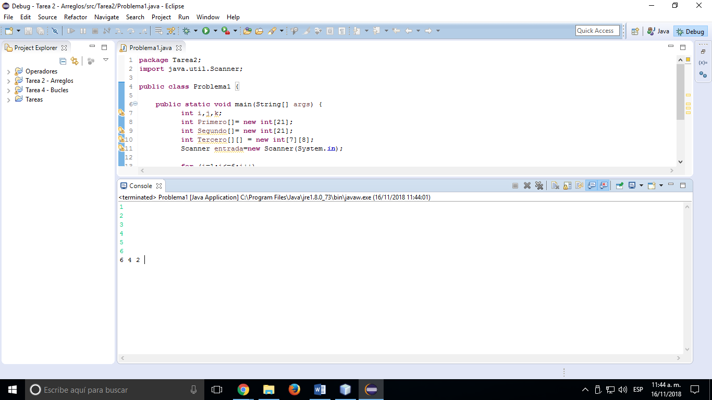

Salida del programa:

**Problema 2:**

**package** Tarea2;

**import** java.util.Scanner;

**public** **class** Problema2 {

**public** **static** **void** main(String[] args) {

**int** i,j,k;

**int** Primero[]= **new** **int**[21];

**int** Segundo[]= **new** **int**[21];

**int** Tercero[][] = **new** **int**[7][8];

Scanner entrada=**new** Scanner(System.***in***);

k=entrada.nextInt();

**for** (i=3;i<=k;)

Segundo[i++]=entrada.nextInt();

j=4;

System.***out***.println(+ Segundo[k]+" "+ Segundo[j+1]);

}

}

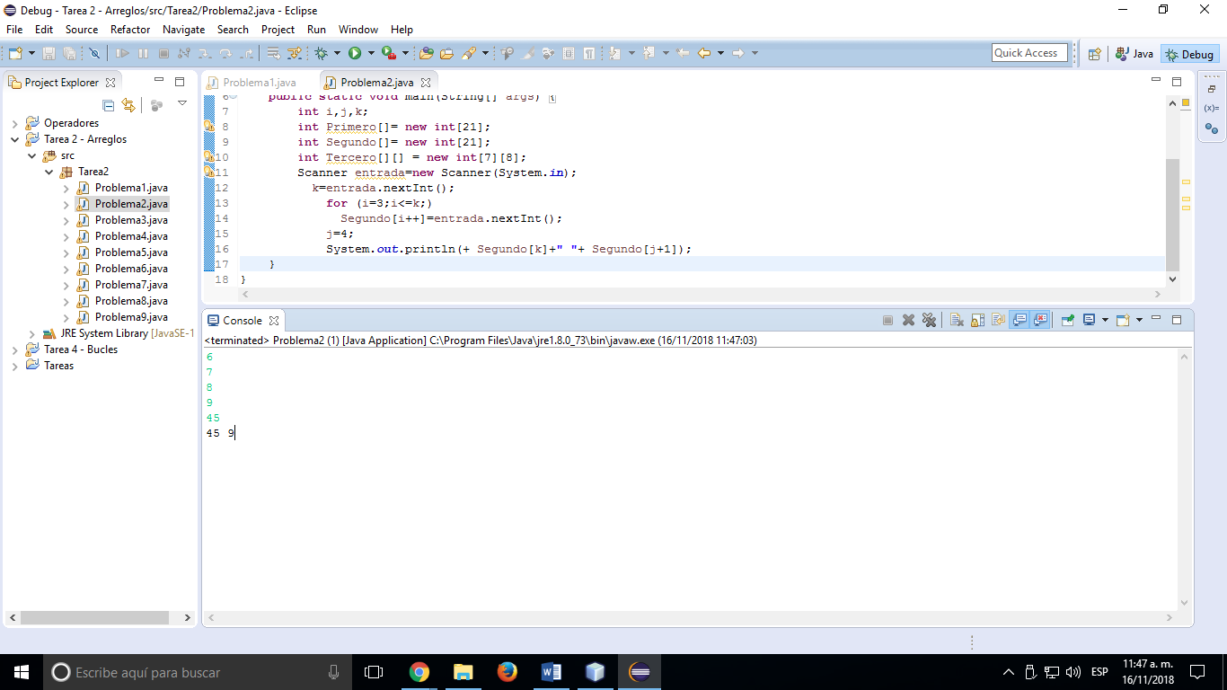

Salida del programa:

**Problema 3:**

**package** Tarea2;

**import** java.util.Scanner;

**public** **class** Problema3 {

**public** **static** **void** main(String[] args) {

**int** i,j,k;

**int** Primero[]= **new** **int**[21];

**int** Segundo[]= **new** **int**[21];

**int** Tercero[][] = **new** **int**[7][8];

Scanner entrada=**new** Scanner(System.***in***);

**for** (i=0;i<10;i++)

Primero[i]=i+3;

j=entrada.nextInt();

k=entrada.nextInt();

**for** (i=j;i<=k;)

System.***out***.println(Primero[i++]);

}

}

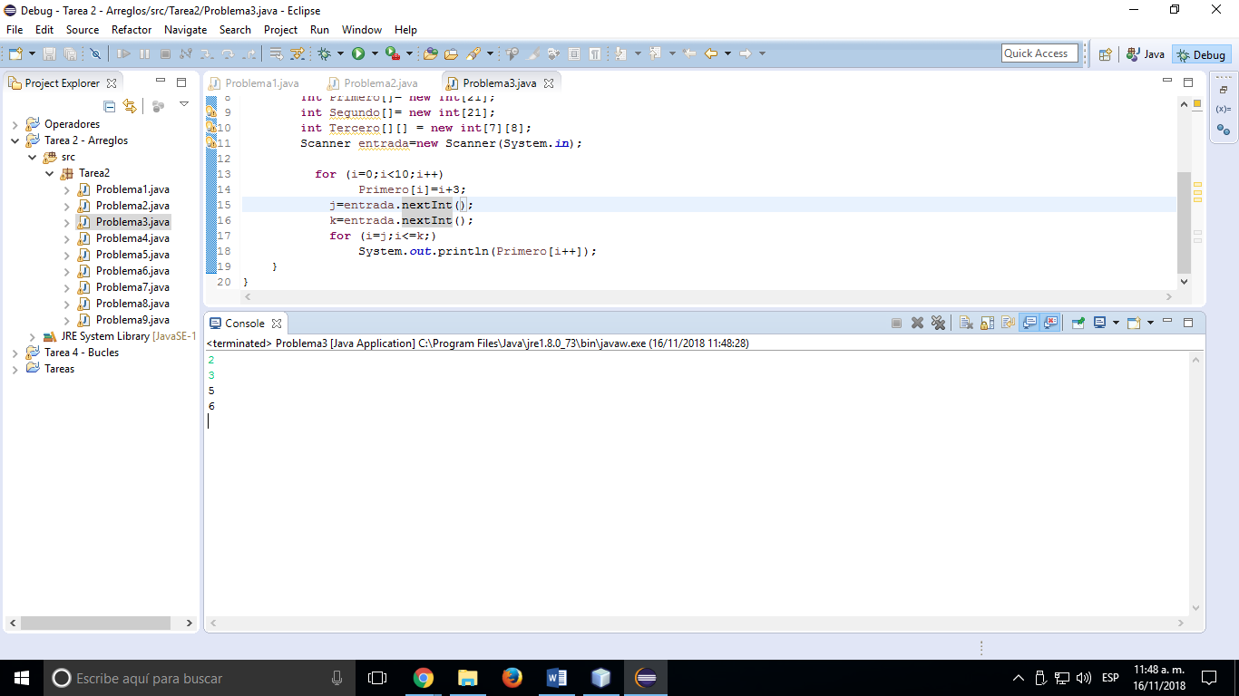

Salida del programa:

**Problema 4:**

**package** Tarea2;

**import** java.util.Scanner;

**public** **class** Problema4 {

**public** **static** **void** main(String[] args) {

**int** i,j,k;

**int** Primero[]= **new** **int**[21];

**int** Segundo[]= **new** **int**[21];

**int** Tercero[][] = **new** **int**[7][8];

Scanner entrada=**new** Scanner(System.***in***);

**for** (i=0;i<12;i++)

Primero[i]=entrada.nextInt();

**for**(j=0;j<6;j++)

Segundo[j]=Primero[2*j]+j;

**for**(k=3;k<=7;k++)

System.***out***.println(Primero[k+1]+" "+Segundo[k-1]);

}

}

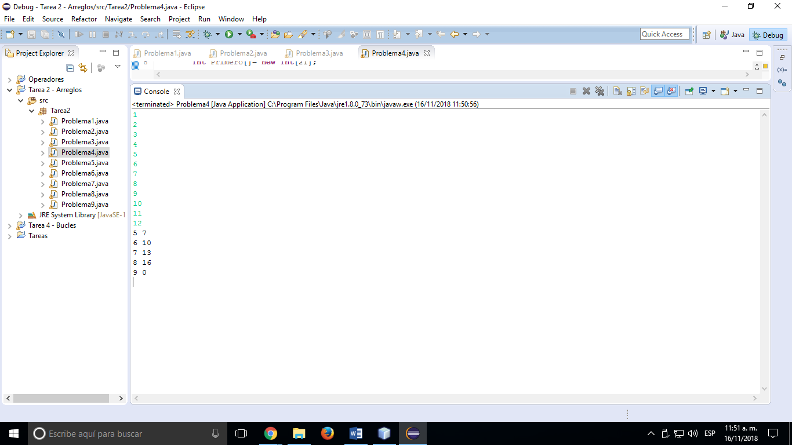Salida del programa:

**Problema 5:**

**package** Tarea2;

**import** java.util.Scanner;

**public** **class** Problema5 {

**public** **static** **void** main(String[] args) {

**int** i,j,k;

**int** Primero[]= **new** **int**[21];

**int** Segundo[]= **new** **int**[21];

**int** Tercero[][] = **new** **int**[7][8];

Scanner entrada=**new** Scanner(System.***in***);

**for** (j=0;j<7;)

Primero[j++]=entrada.nextInt();

i=0;

j=1;

**while** ( (j<6) && (Primero[j-1] <Primero[j] ))

{

i++;j++;

}

**for** (k=-1;k<j+2;)

System.***out***.println(Primero[++k]);

}

}

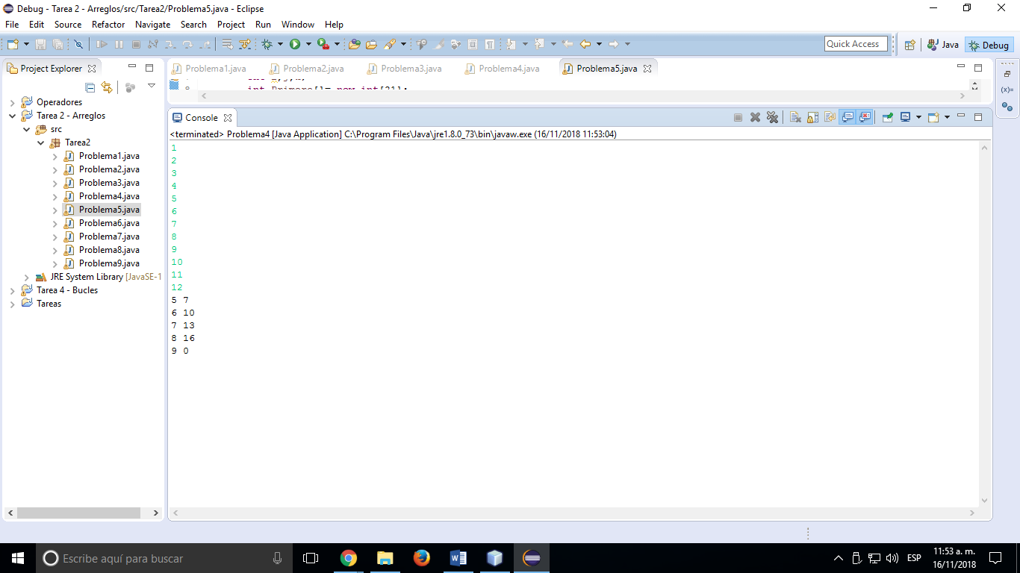Salida del programa:

**Problema 6:**

**package** Tarea2;

**import** java.util.Scanner;

**public** **class** Problema6 {

**public** **static** **void** main(String[] args) {

**int** i,j,k;

**int** Primero[]= **new** **int**[21];

**int** Segundo[]= **new** **int**[21];

**int** Tercero[][] = **new** **int**[7][8];

Scanner entrada=**new** Scanner(System.***in***);

**for** (i=0;i<3;i++)

**for**(j=0;j<12;j++)

Tercero[i][j]=i+j+1;

**for**(i=0;i<3;i++)

{

j=2;

**while** (j<12)

{

System.***out***.println(i+" "+j+" "+ Tercero[i][j]);

j+=3;

}

}

}

}

**Problema 7:**

**package** Tarea2;

**public** **class** Problema7 {

**public** **static** **void** main(String[] args) {

**int** suma = 0;

**int** arreglos[][] = {{4,7,1,3,5},{2,0,6,9,7},{3,1,2,6,4}};

**int** a[] = {4,7,1,3,5};

**int** e[] = {2,0,6,9,7};

**int** i[] = {3,1,2,6,4};

System.***out***.println(a[0] + " " + e[0] + " " + i[0]);

System.***out***.println(a[1] + " " + e[1] + " " + i[1]);

System.***out***.println(a[2] + " " + e[2] + " " + i[2]);

System.***out***.println(a[3] + " " + e[3] + " " + i[3]);

System.***out***.println(a[4] + " " + e[4] + " " + i[4]);

}

}

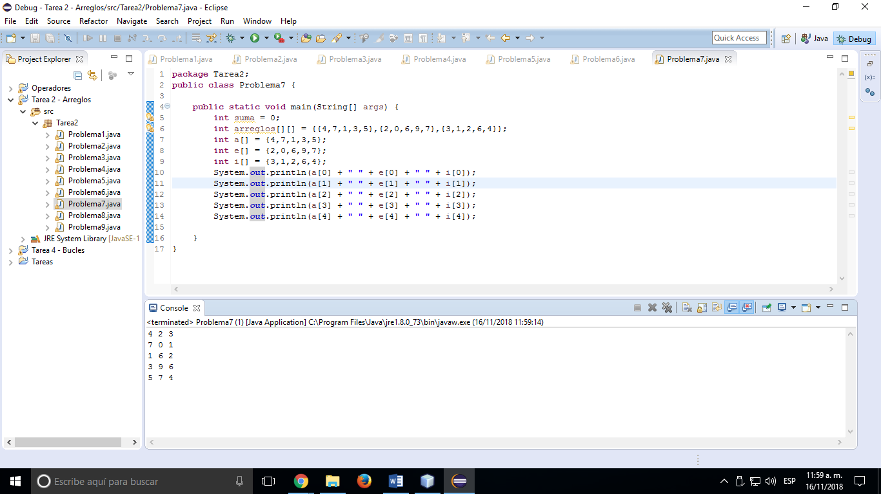

Salida del programa:

**Problema 8:**

**package** Tarea2;

**public** **class** Problema8 {

**public** **static** **void** main(String[] args) {

**int** suma = 0;

**int** arreglos[][] = {{4,0,1,6},{7,3,2,1},{-5,-2,4,0},{4,6,1,3},{9,-2,1,-4}};

**int** a[] = {4,0,1,6};

**int** e[] = {7,3,2,1};

**int** i[] = {-5,-2,4,0};

**int** o[] = {4,6,1,3};

**int** u[] = {9,-2,1,-4};

System.***out***.println(a[0] + " " + e[0] + " " + i[0] + " " + o[0] + " " + u[0]);

System.***out***.println(a[1] + " " + e[1] + " " + i[1] + " " + o[1] + " " + u[1]);

System.***out***.println(a[2] + " " + e[2] + " " + i[2] + " " + o[2] + " " + u[2]);

System.***out***.println(a[3] + " " + e[3] + " " + i[3] + " " + o[3] + " " + u[3]);

**int** suma_diagonal_principal = (a[0] + e[1] + i[2] + o[3]);

**int** suma_de_todos_los_elementos = (a[0] + a[1] + a[2] +

e[0] + e[1] + e[2] + e[3] + i[0] + i[1] + i[2] + i[3] +

o[0] + o[1] + o[2] + o[3] + u[0] + u[1] + u[2] + u[3]);

**int** resultado = suma_de_todos_los_elementos - suma_diagonal_principal;

System.***out***.print("Suma de todos los elementos que no pertenecen a la diagonal principal = " + resultado);

}

}

Salida del programa:

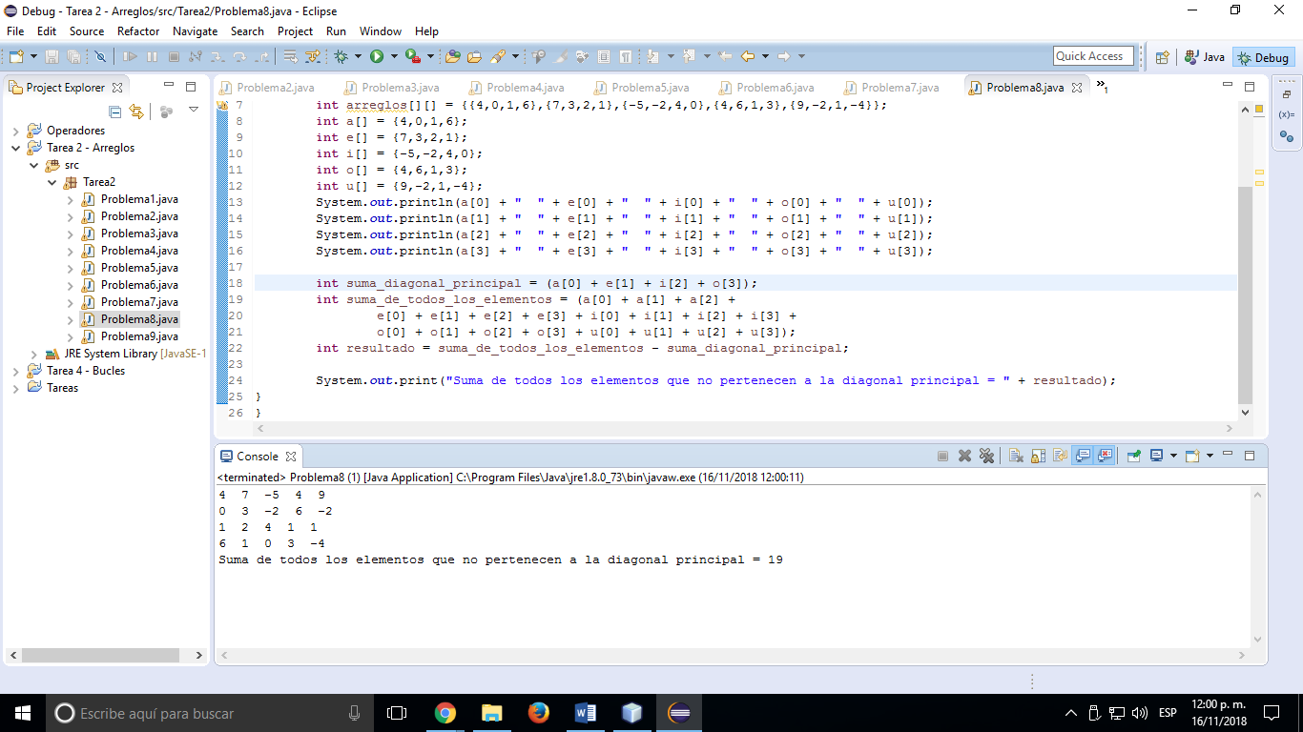

**Problema 9:**

**package** Tarea2;

**public** **class** Problema9 {

**public** **static** **void** main(String[] args) {

**int** suma = 0;

**int** arreglos[][] = {{1,2},{3,4}};

**int** m[] = {1,2,3};

**int** x[] = {4,5,6};

**int** n[] = {7,8,9};

System.***out***.println("ARREGLO ORIGINAL");

System.***out***.println(m[0] + " " + x[0] + " " + n[0]);

System.***out***.println(m[1] + " " + x[1] + " " + n[1]);

System.***out***.println(m[2] + " " + x[2] + " " + n[2]);

System.***out***.println("");

System.***out***.println("INTERCAMBIO");

System.***out***.println(m[2] + " " + x[2] + " " + n[2]);

System.***out***.println(m[1] + " " + x[1] + " " + n[1]);

System.***out***.println(m[0] + " " + x[0] + " " + n[0]);

}

}

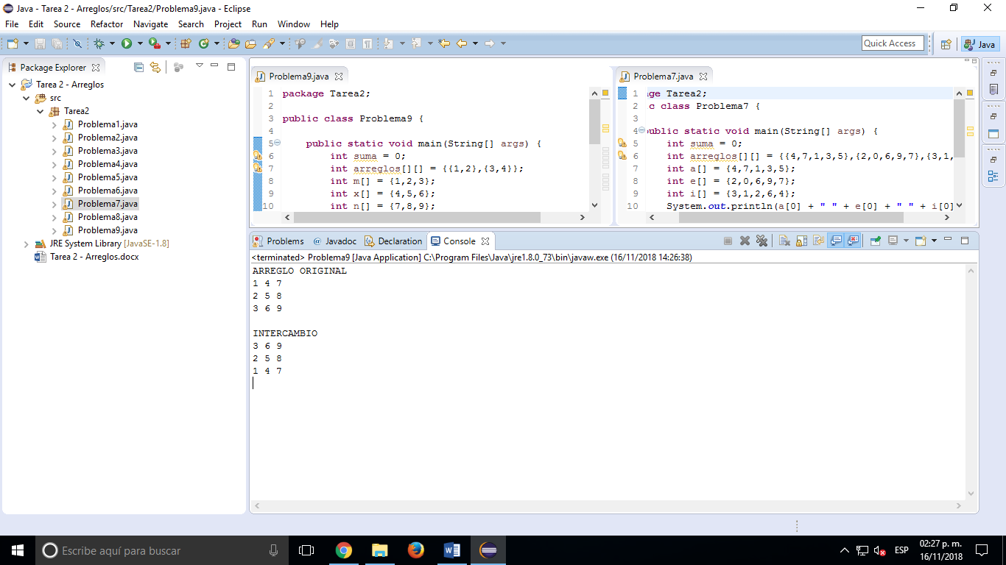Salida del programa: